Course Specialist Year 12 Test One 2022

Student name: ________________ Teacher name: ________________

Task type: Response

Time allowed for this task: _____40______ mins

Number of questions: _____8______

Materials required: Calculator with CAS capability (to be provided by the student)

Standard items: Pens (blue/black preferred), pencils (including coloured), sharpener, correction fluid/tape, eraser, ruler, highlighters

Special items: Drawing instruments, templates, notes on one unfolded sheet of
A4 paper, and up to three calculators approved for use in the WACE examinations

Marks available: __42____ marks

Task weighting: _10___%

Formula sheet provided: Yes/No

Note: All part questions worth more than 2 marks require working to obtain full marks.

Q1 (2, 3 & 3 = 8 marks) (3.1.1- 3.1.6)
Let and .
Simplify the following.

- (simplify)

Q2 (3 marks) (3.1.1-3.1.3)
Determine all possible real number pairs such that

Q3 (3 marks) (3.1.13-3.1.15)
Consider the polynomial where are real numbers.
Given that and determine the values of .

Q4 (3 marks) (3.1.8-3.1.10)
Using the diagram below determine the complex number in exact cartesian form.
(Note: Not drawn to scale)

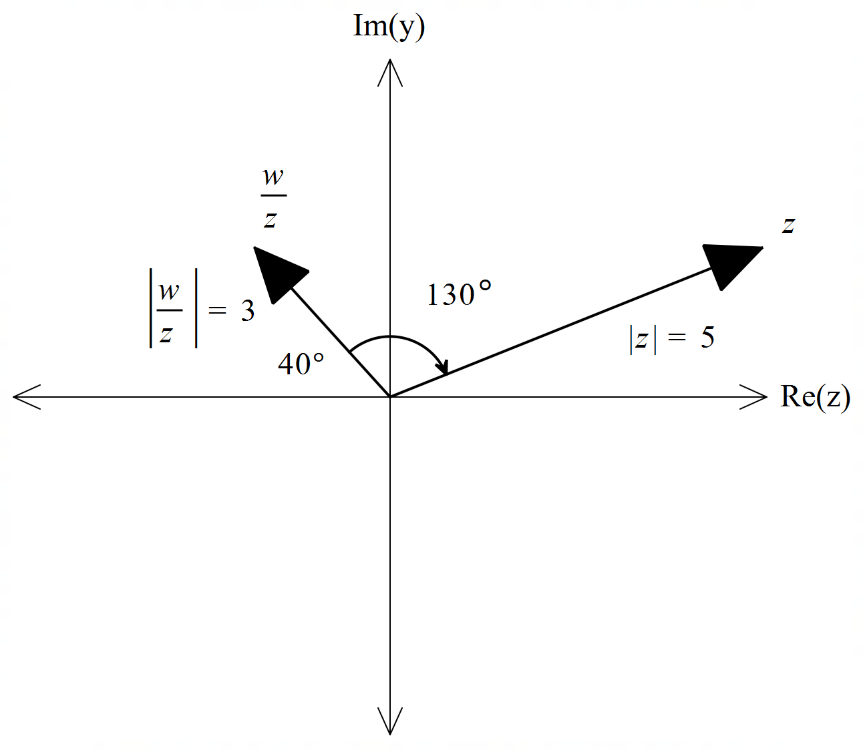

Q5 (3 & 3= 6 marks) (3.1.10)
Sketch the locus for the following labelling important features and points.

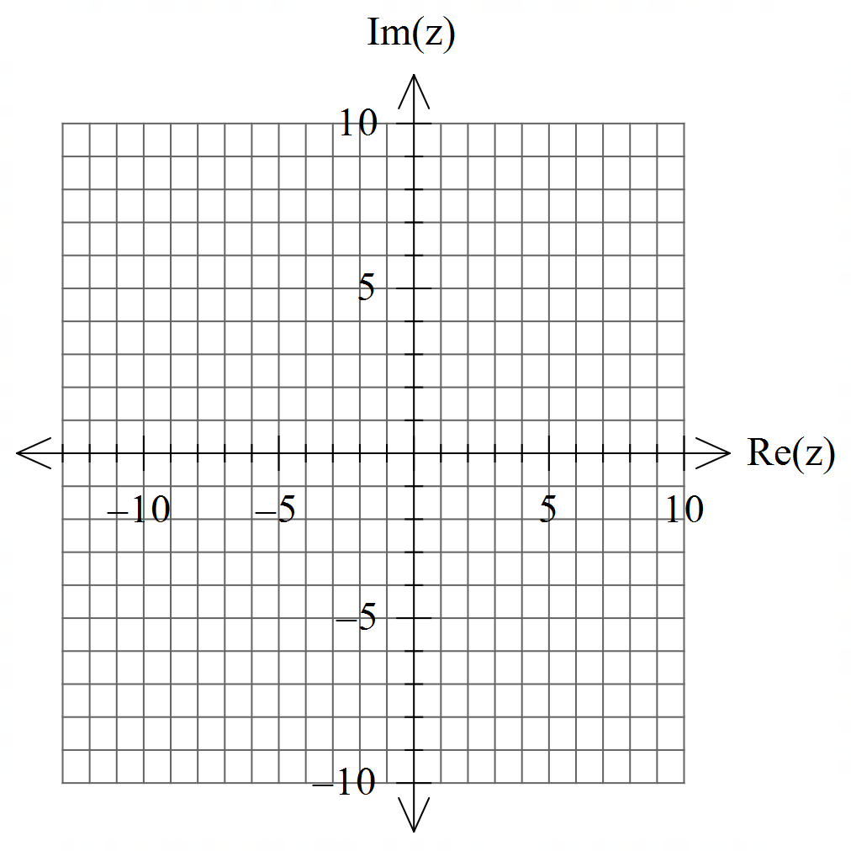

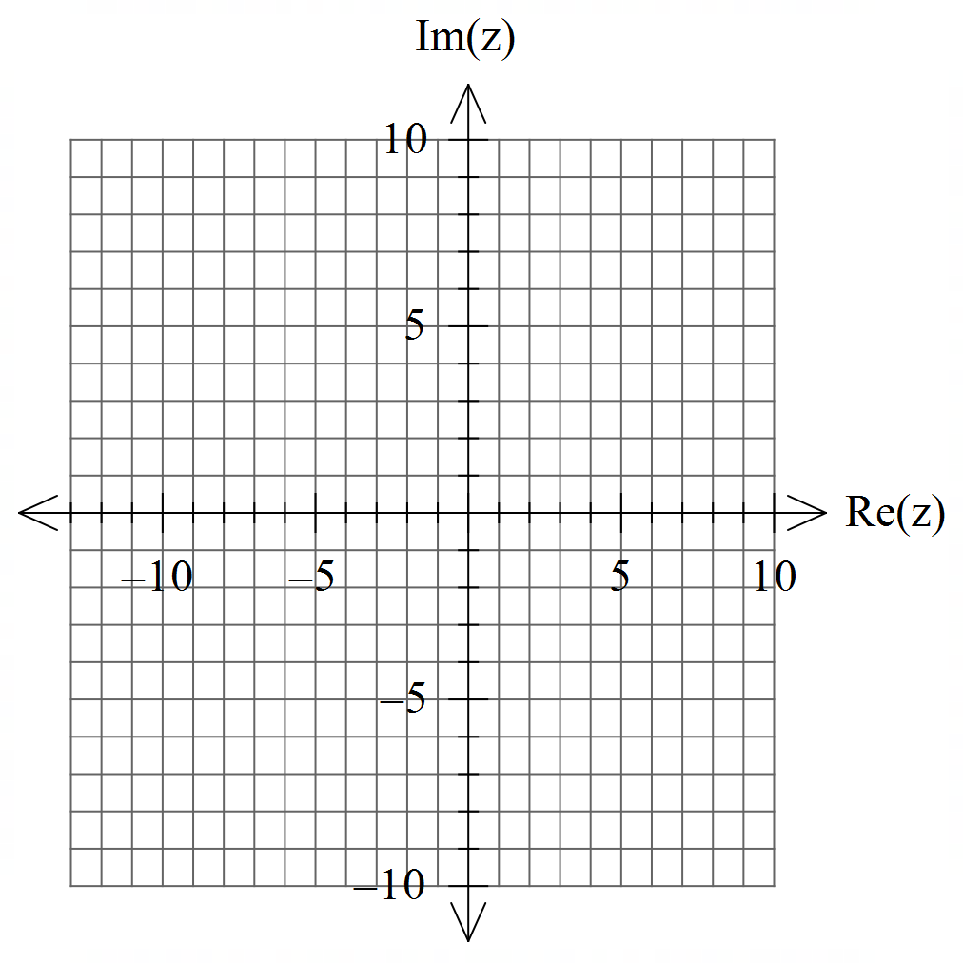

Q6 (2 & 4 = 6 marks) (3.1.10)
Consider the set of points in the complex plane such that .
- Determine the maximum value of .

- Determine the maximum value of .

Q7 (4 marks) (3.1.7)
Using De Moivre’s Theorem, derive an expression for in terms of .

Q8 (4, 2 & 3 = 9 marks) (3.1.11-3.1.12)

- Solve for all the roots in polar form with .

- Plot these roots on the complex plane below.
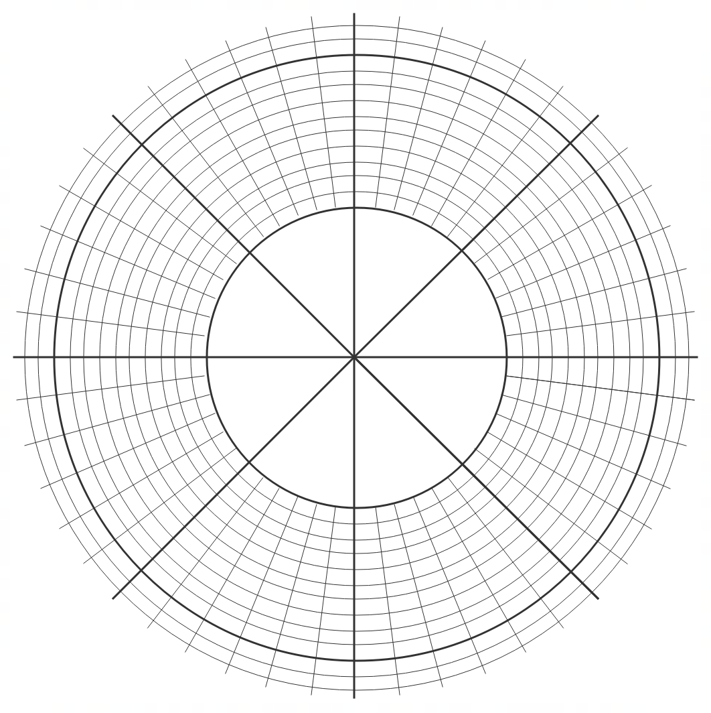

- Adjacent points can be joined by lines to form a polygon. Determine the exact area of this polygon.

Working out space

Working out space

